How to Remove text from numbers in Excel

In Excel, you may need to remove text from numbers in certain situations, such as when you want to perform mathematical calculations on a column of data that includes both numbers and text. Excel treats text and numbers differently, and if you have numbers stored as text, it can lead to errors or unexpected results in calculations.

## Case 1 – When alphanumeric data follow the same pattern

Here's a practical scenario where we have a sales data table for a store that sells fruits. The data includes the quantity of fruits sold and their respective weights, but the weights are stored as text and include the unit "kg". We need to remove the "kg" from the weights to convert them into numerical values for further analysis.

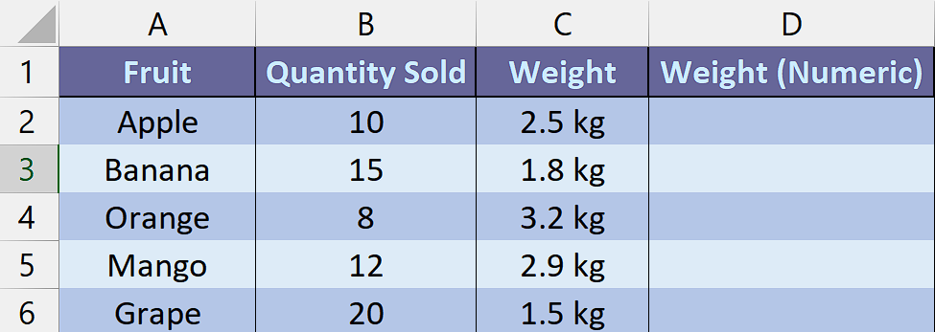

## Method 1 – By using VALUE and SUBSTITUTE Functions

## Step 1 – Selecting the cell

* Select **any empty cell** in which we want the result containing numbers only.
* In this cell, we will apply the VALUE and SUBSTITUTE Functions to get our desired results.



## Step 2 – Writing the formula

* Copy and paste the following formula in the selected cell.

=VALUE(SUBSTITUTE(C2, " kg", ""))

* Here is the breakdown of the formula,
* **C2:** This refers to the **cell C2** in the Excel worksheet. It represents the first cell in the "Weight" column, where the **original weight value is stored** (e.g., "0.5 kg" for the Apple).
* **SUBSTITUTE(C2, " kg", ""):**

The **SUBSTITUTE function is used to replace a specified text** within a given text (C2) **(" kg" in this case** **but** you **will write the text that you want to remove)** with another text **(an empty string "").**

* So, this part of the formula replaces the **" kg" text** in the weight value with nothing, **effectively removing it.**
* For example, if **C2 contains "2.5 kg",** this part of the formula would **remove " kg" and leave "2.5".**
* **VALUE(SUBSTITUTE(C2, " kg", "")):**

The **SUBSTITUTE function returns a text value.** However, in order to perform calculations or use numerical functions on the weight values, we need to convert them into numbers. The **VALUE function is used here to convert the resulting text (after removing " kg") into a number.**

* For instance, if the result of the **SUBSTITUTE function is "2.5",** the **VALUE** **function** would **convert** it to the **numeric value 2.5.**
* After writing the formula, **press Enter** and **result would appear in the cell.**



## Step 3 – Applying the formula to the whole range

* For applying the formula on the whole range, select the cell in which result is present. For example, it is **D2 cell** in our case.
* Then move your cursor on the **right bottom corner of the cell,** and your cursor would turn into **+ shape** which is called the fill handle.
* **Double-Click** on this **fill handle** and the formula would be applied to the whole range.



## Method 2 – By using function created with VBA code

## Step 1 – Adding a module

* For adding a module, navigate to **Developer tab.**
* After that, click on the **first option** named as **Visual basic.**
* You’ll see a **new window on your screen** and you can **also** **open this window** by using **shortcut key** (**Alt+F11**) as well.
* Then, click on the **Insert tab** in this window and click on the **Module option.**
* Now, a **new module would open.**



## Step 2 – Writing the code

* Just copy and paste the following code in the white area of entered module.

Function Rmv_Text(textValue As String) As Double

Dim numericValue As Double

Dim numericPart As String

' Extract numeric part from the text

numericPart = ""

For i = 1 To Len(textValue)

' Check if the character is numeric or a decimal point

If IsNumeric(Mid(textValue, i, 1)) Or Mid(textValue, i, 1) = "." Then

' Append the numeric character to the numeric part

numericPart = numericPart & Mid(textValue, i, 1)

End If

Next i

' Convert the numeric part to a number

numericValue = Val(numericPart)

Rmv_Text = numericValue

End Function

* Then, use shortcut key **“Ctrl+Q”** to close the VBA Editor.



## Step 3 – Selecting the cell

* **Select an empty cell** in which you want to get the result with separated text from numbers such as **cell D2.**
* In this **selected cell**, we will **apply the function** created by us using **VBA code** to **remove text from numbers.**



## Step 4 – Using the created Function

* **Press** **= (equal sign) button** on your keyboard in the **selected cell.** For example, **cell D2.**
* Then, type **“Rmv_Text”** (without quotes) and **select this function** from the list by using **tab button.**
* Now, select or **enter the name of the cell** from which you want to remove the text. For instance, it is the **cell C2.**
* **Add closing parenthesis** and **press Enter.**
* The **result would appear** in the **cell D2** which **contains numbers without text.**



## Step 5 – Applying the formula to the whole range

* For applying the formula on the whole range, select the cell in which result is present. For example, it is **D2 cell** in our case.
* Then move your cursor on the **right bottom corner of the cell,** and your cursor would turn into **+ shape** which is called the fill handle.
* **Double-Click** on this **fill handle** and the formula would be applied to the whole range.



## Case 2 - When alphanumeric data is mixed

The dataset below can be used for various purposes, such as analyzing geographical distributions or conducting contact-based analysis. This dataset contains information about individuals including their names, addresses, and phone numbers. Each row represents a different person. The "Name" column lists the individual's name. The "Address" column provides the full address of each person, including the street name, city, state, and zip code. The "Phone Number" column displays the contact phone number for each individual. The "Address in numbers" column should ideally contain the numerical representation of the address, with any text or non-numeric characters removed and in today’s tutorial, we will learn how to remove text from these numbers.

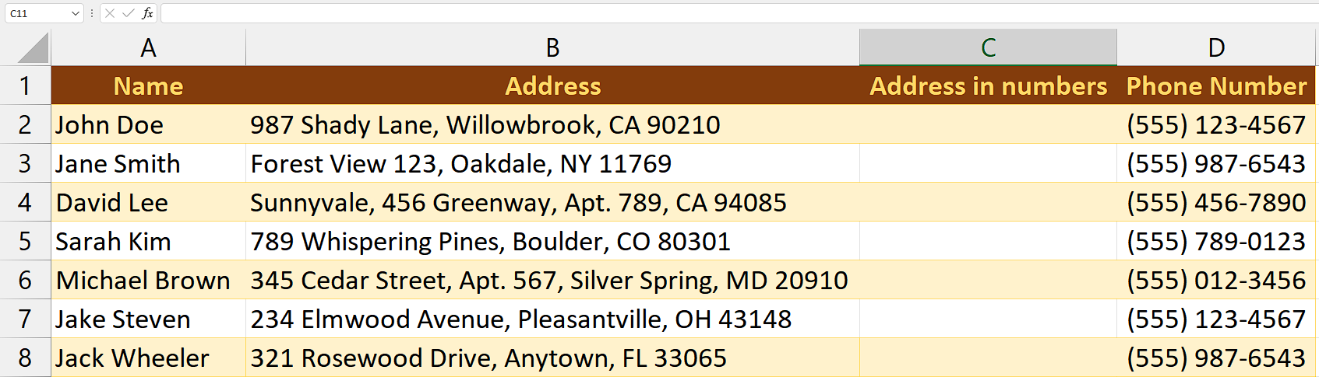

## Method 1 – By Using a VBA code

## Step 1 – Adding a module

* For adding a module, navigate to **Developer tab.**
* After that, click on the **first option** named as **Visual basic.**
* You’ll see a **new window on your screen** and you can **also** **open this window** by using **shortcut key** (**Alt+F11**) as well.
* Then, click on the **Insert tab** in this window and click on the **Module option.**
* Now, a **new module would open.**



## Step 2 – Writing the code

* Just copy and paste the following code in the white area of entered module.
* You will have to modify the code according to your need.

Sub ExtractNumbersFromAddress()

Dim lastRow As Long

Dim addressRange As Range

Dim cell As Range

' Set the range of the "Address" column

lastRow = Cells(Rows.Count, "B").End(xlUp).Row

Set addressRange = Range("B2:B" & lastRow)

' Loop through each cell in the "Address" column

For Each cell In addressRange

' Remove non-numeric characters and update the "Address in numbers" column

cell.Offset(0, 1).Value = ExtractNumbers(cell.Value)

Next cell

End Sub

Function ExtractNumbers(ByVal text As String) As String

Dim result As String

Dim i As Integer

Dim c As String

' Loop through each character in the input text

For i = 1 To Len(text)

c = Mid(text, i, 1)

' Check if the character is a digit

If IsNumeric(c) Then

result = result & c

End If

Next i

' Return the extracted numbers

ExtractNumbers = result

End Function

* Then, use shortcut key **“Ctrl+Q”** to close the VBA Editor.



## Step 3 – Running the macro

* Go to the **"Developer" tab** on the Excel ribbon and click on the "**Macros" button** in the **"Code" group.**
* Select the Macro named **“ExtractNumbersFromAddress”.**
* Double-Click on it or click on Run.
* It will run the macro and all numbers from the Addresses and will be extracted and written in **“Address in numbers” column.**
* **In this way,** we can **remove text from numbers.**

